**SHRI VAISHANAV VIDHYAPEETH VISHWAVIDYALAYA**



**SHRI VAISHNAV INSTITUTE OF INFORMATION**

**TECHNOLOGY**

PROJECT REPORT

APPLICATION REVIEW SYSTEM

**Developed By:**

Pooja Khandekar

**Project Guide-**

APPLICATION REVIEW SYSTEM

**INDEX**

1. Introduction to Business Intelligence…………………………………01
2. Overview of Cognos…………………………………………………..02
3. Acknowledgement………………………………………………….....05
4. Disclaimer……………………………………………………………..06
5. Scope…………………………………………………………………..07
6. Assumptions ………………………………………………………….08
7. Database parameters………………………………………………..…09

* Data module 1
* Data module 2

1. Analogical Diagram…………………………………………………...11
2. Prediction Methods……………………………………………………13

* Comparison factors
* Visualisation Tools

1. Outcome Achieved……………………………………………………17

1. Dashboard screenshots………………………………………………..19

**Introduction Business Intelligence**

* Business intelligence (BI) leverages software and services to transform data into actionable intelligence that informs an organization’s strategic and tactical business decisions.

* BI tools access and analyze data sets and present analytical findings in reports, summaries, dashboards, graphs, charts and maps to provide users with detailed intelligence about the state of the business.
* Business intelligence (BI) is a variety of software applications used to analyze an organization's raw data. BI can include data mining, online analytical processing, and business reporting. Most businesses use BI software to help keep track of information and rely on the software to operate effectively.

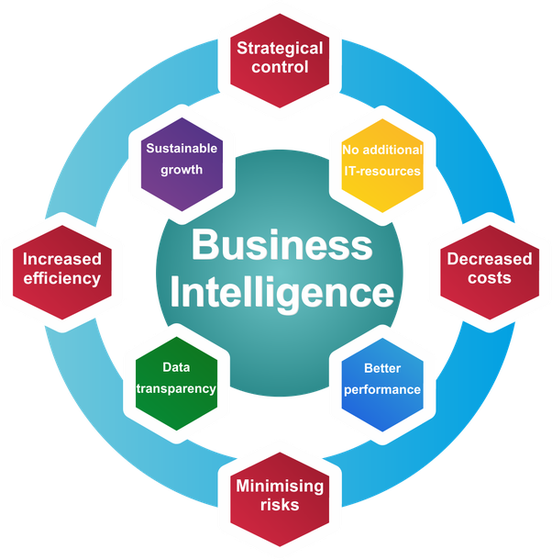

**Overview of Cognos**

* Cognos was an Ottawa, Ontario-based company making business intelligence and performance management software.
* Founded in 1969, at its peak Cognos employed almost 3,500 people and served more than 23,000 customers in over 135 countries until being acquired by IBM on January 31, 2008.
* IBM Cognos Business Intelligence is a web-based integrated business intelligence suite by IBM. It provides a toolset for reporting, analytics, scorecarding, and monitoring of events and metrics.
* The software consists of several components designed to meet the different information requirements in a company.
* **Basic components**

The elements described below are web-based components that can be accessed from most popular browsers (IBM Cognos specifically supports Mozilla Firefox, Google Chrome and Internet Explorer).

1. Cognos Connection

Cognos Connection is the Web portal for IBM Cognos BI. It is the starting point for access to all functions provided with the suite. Using this portal, content can be searched in the form of reports, scorecards and agents, it can be managed, structured and displayed.

1. Query Studio

Query Studio allows simple queries and self-service reports to answer basic business questions. The report layout can be customized and data can be filtered and sorted. Formatting and creation of diagrams is also supported.[1]

1. Report Studio

The Report Studio is used to create management reports. It offers two different modes: The professional authoring mode enables users to access the full range of Report Studio functionality. In this mode, users can create any type of report, including charts, maps, lists, and repeat functions. In professional authoring mode all types of Data (relational or multidimensional) can be used, but dynamic data can not be displayed.[1]

1. Analysis Studio

OLAP-functionalities Drill-up and drill-down as example OLAP-functionalities Users can create analyses of large data sources and search for background information about an event or action. Multidimensional analysis allows identifying trends and understanding of anomalies or deviations, which are not obvious in other types of reports.

1. Event Studio

The Event Studio is a notification tool that informs about events within the enterprise in real time. Therefore, agents can be created to detect the occurrence of business events or exceptional circumstances, based on the change of specified event- or data conditions.

1. Workspace

IBM Cognos Workspace (formerly introduced in version 10.1 as IBM Cognos Business Insight and renamed in version 10.2.0) is a web-based interface that allows business users to use existing IBM Cognos content (report objects) to build interactive workspaces for insight and collaboration.

1. Workspace Advanced

IBM Cognos Workspace Advanced (formerly introduced in version 10.1 as IBM Cognos Business Insight Advanced and renamed in version 10.2.0) is a web-based interface that allows business users to author/create reports and analyze information.

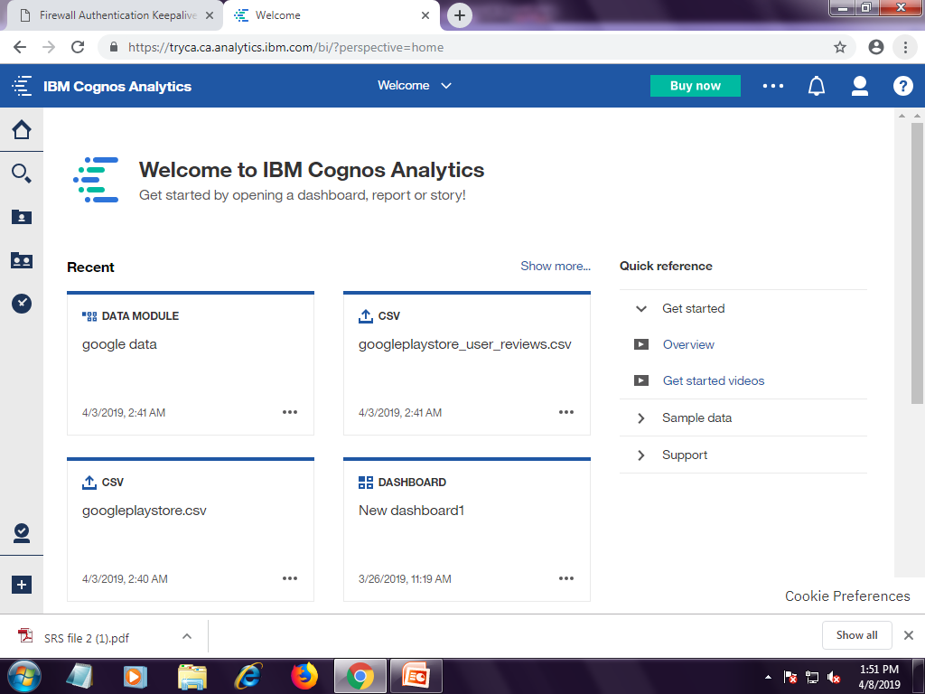

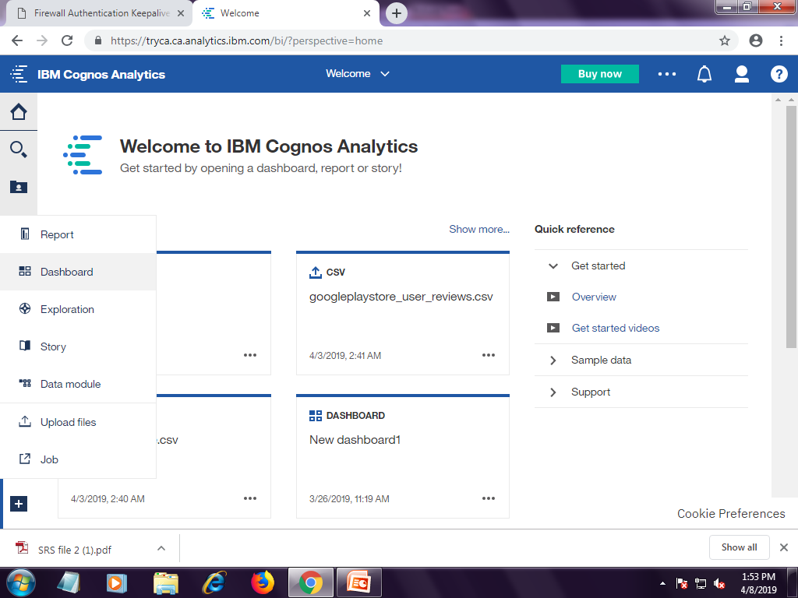

**Basic UI of IBM Cognos**

**Acknowledgement**

We would like to express our gratitude towards our faculty and our university Shri Vaishnav Vidyapeeth Vishwavidyalaya, for providing us with the opportunity of creating a dataset Analytic report using the online IBM Cognos Analytic tool.

This project enhanced our technical and practical approach towards the in depth skills and technicalities related to Big Datasets and its analysis measures. The knowledge of practical aspects of IBM Cognos tool were also strengthen by being engaged in this project.

Also, we would like to thank the whole IBM team for guiding us and helping us to finalise this project within the limited time frame.

**Disclaimer**

This Software Requirements Specification document is a guideline. The document details all the high level requirements. The document should be used as a guideline by the students to design the Solution Architecture for the project. The document also describes the broad scope of the project and high level DB requirements are captured in the DB specification. But while developing the solution if the developer has a valid point to add more details being within the scope specified then it can be accommodated after consultation.

**Scope**

This document describes the scope of the requirements for the descriptive and predictive analysis for an App development company, majoring in Android related market. The document details all the high level requirements with intent to validate the requirements of the aforethought company*.* This document should be used by the Architect and the developers to design the Solution Architecture for the project. In addition to this, the document also describes the broad scope of the project. The scope of the project involves the integration of a subset of all the components of current IT environment.

The application review system entails all the specific detail needed by an individual app belonging to a defined broad category. The system works as a platform for the applications and their categories to analyse the market potential for a certain applications before its actual launching. It also helps to visualise the distribution and correlations between different app features by the use of categories.

**Assumptions**

The following assumptions are undertaken in respect to the working of the system:

* The ratings and reviews are presented by true and verifiable consumers and not an automated system.
* All sectors and subdivisions has been rated according to a unified and just system.
* The developer rating is not considered separately and their (individual/ organisation) comments are nullified.
* The product rating is not based by the consumers and critics by previous correspondences with the App Developer.
* All apps are rated with negligence towards any monetary transactions by the critic or the App Developer.
* The Apps rated by the consumers are genuinely downloaded and tested before reviewing them.

**Database Parameters**

The data is analysed on the basis of any numerical or other measurable factor forming one of a set that defines a system or sets the conditions of its operation. The data here, is analysed from two different data modules.

**Data module 1:**

This contains information about both, the individual App and details for its specified category.

The headers are

* App-Application name
* Category- Classification based on the type of app
* Rating-Overall user rating of the app
* Reviews-Number of user reviews for the app
* Size-Size of the app in MBs
* Installs-Number of user downloads for the app
* Type-Paid or Free
* Price-Price of the app
* Content Rating-Age group the app is targeted at - Children / Mature 21+ / Adult
* Genres-An app can belong to multiple genres (apart from its main category). For eg, a musical family game will belong to Music, Game, Family genres.
* Last Updated-Date when the app was last updated on Play Store
* Current Ver-Current version of the app available on Play Store
* Android Ver-Min required Android version

**Data module 2:**

The dataset is made to adhere the needs of a specific apps, based on the terms of its user reviews.

The headers are:

* App-Name of app
* Translated_Review-User review (Preprocessed and translated to English)
* Sentiment-Positive/Negative/Neutral (Preprocessed)
* Sentiment_Polarity-Sentiment polarity score
* Sentiment_Subjectivity-Sentiment subjectivity score

**Analogical Diagram**

The diagram depicted below shows the basic working of Application Review system which entails the 3 basic platform prerequisite for its basic architecture.

The application review system acts as a mediating platform which connects and bounds the various independent platforms.

These are:

* **Applications-** A mobile app or mobile application is a computer program or software application designed to run on a mobile device such as a phone/tablet or watch. In this Application Review System, apps acts as the “raw material” on which the processing is to be done.
* **Reviews-** the critical appraisal provided by various users, consumers and other app developers using a just system and ratings provided are the reviews on the application or the categorical differentiation for it. The reviews acts as a parameter for judging the app or their category as a whole.
* **Trends-** The final output generated from usage of Application Review system gives us the general idea of the future changes and development

**(Diagram on next page)**

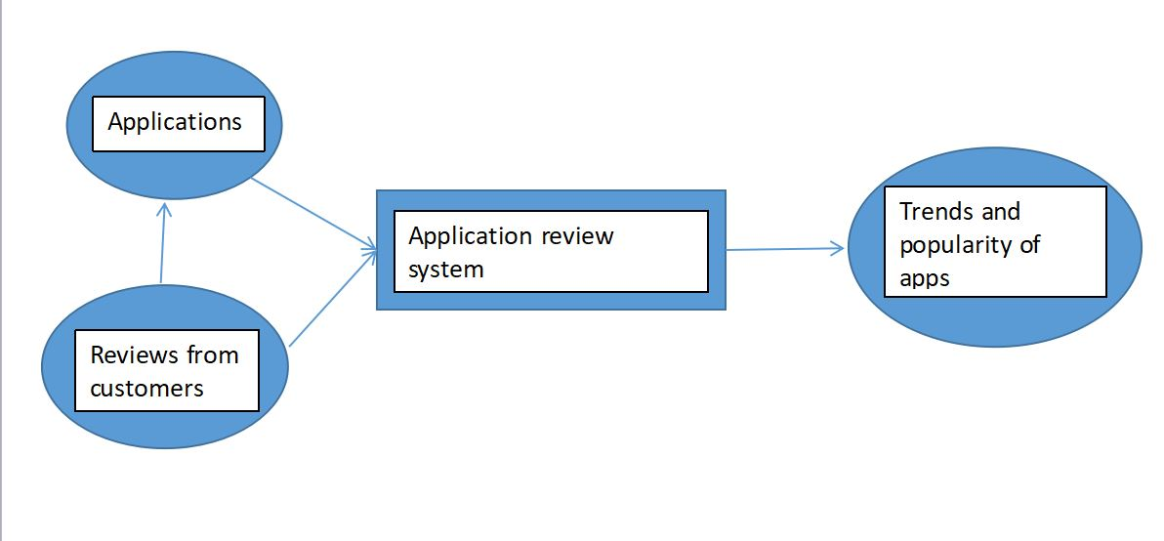

**Analytical diagram representing the overview of**

**Application Review System**

**Prediction Methods**

Online tool, Cognos by IBM integrates reporting, modeling, analysis, exploration, dashboards, stories, and event management so user can understand your organization's data, and make effective business decisions.

Use of dashboard and visualisation tools is done in order to create data reports which helps the user to monitor events or activities at a glance by providing key insights and analysis about data on one or more pages or screens.

The data is differentiated on the basis of two aspects namely, categories and the apps belonging to that category.

Many features are used compare and contrast between different datasets and the prompts used here are the categories and apps.

**Comparison factors:**

Comparison factor is systematic and scientific method designed to carry out job evaluation which instead of ranking job as a whole, ranks according to a series of factors.

The analysis here, is influenced by the characteristics of:

1. App Ratings: To verify the user performance
2. App Reviews: The verbal comments by the users. Pre decided keywords are used to analyse these.
3. Number of installs: To check popularity of an app.
4. The size of the Apps: To weigh the memory related gains and losses

**Visualisation tools:**

Visualisation is any technique for creating images, diagrams, or animations to communicate a message. Visualization through visual imagery has been an effective way to communicate both abstract and concrete ideas since the dawn of humanity.

The IBM Cognos tools provides it users with plenty inbuilt visualisation options to choose from. The tool must be so chosen that it fulfils the conditions of ‘categories’ and ‘values’ provided by IBM Cognos.

Here the charts used for analysis of data are:

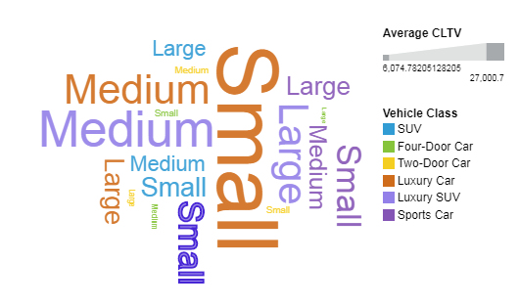 **Word clouds:** It is a novelty visual representation of text data, typically used to depict keyword metadata on websites, or to visualize free form text. Tags are usually single words, and the importance of each tag is shown with font size or color.

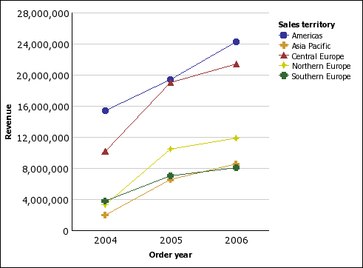 **Line charts:** A line chart or line graph is a type of chart which displays information as a series of data points called 'markers connected by straight line segments. It is a basic type of chart common in many fields.

**Radar:** Radar charts provide quick focus on the areas that are in most need of attention, by providing a visual view of a set of metrics, and how they relate or differ. ... Each radial of a radar chart is a metric, and a minimum of three metrics are required. The metric data is plotted in relation to one anchored metric.

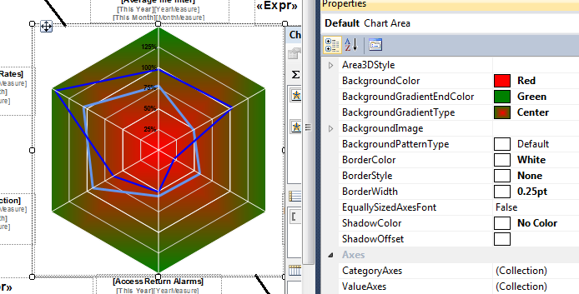

**Bar graphs:** A bar graph (also known as a bar chart or bar diagram) is a visual tool that uses bars to compare data among categories. A bar graph may run horizontally or vertically. The important thing to know is that the longer the bar, the greater its value. Bar graphs consist of 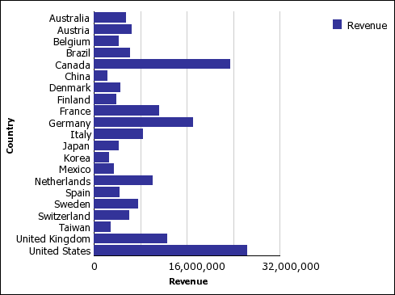two axes.

**Outcome Achieved**

A detailed examination of the elements or structure of dataset(s) is concluded using a dashboard which gives the company insights of the different categorical information for a specific sector. The investigation of an application category is concluded according to its user rating. This gives the aforementioned company details about the market space and user preferences.

The dataset is analysed on the basis of categories comparing between apps present. The rating of several related apps is plotted to give particulars of the rise and fall of performance between users of apps in the specified category. This subsequently helps the company to launch its product in the sector.

The popularity of app is determined on the basis of the total number of times it is downloaded. The Application Review System provides the company with the facility of keeping a check on the popularity of their app with market completion and develop their app according to the user demand.

The total number of installs can also be calculated for a sector of business, this helps the respective company to select their area for app development. Eventually the Research and Development sector of company gains from the Application Review System.

The information about a distinct app is easy to gather using this system as it entails the description of one definite app. The consumer comments are filtered using keywords and the one with maximum percentage decides the fate of the application for the market.

The company can use direct analysis methods to find bugs of an app. The size of an app can also be distinguished and the one which takes least area can be segregated out. This helps the company to step a foot ahead with their market competition in terms of memory usage.

This also helps the beta developers in an indirect way as they get a direction and new ideas to work on, which are genuinely needed in the market, by the customers. This also reduces the chances of application failure in the market by enormous amount.

The need for platform like Application Review system is the need of the hour where skilled labour is available in immense quantity and start-ups are gaining much more popularity than ever before.

**Dashboard Screenshots**

**Main page**

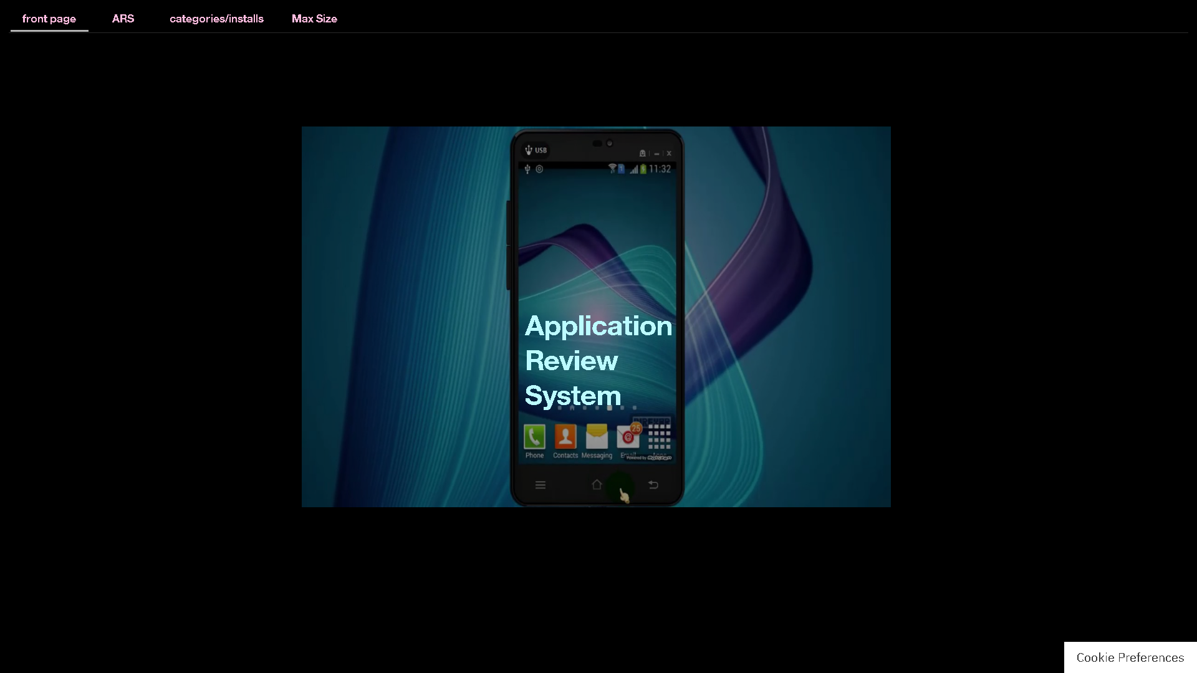

**main dashboard**

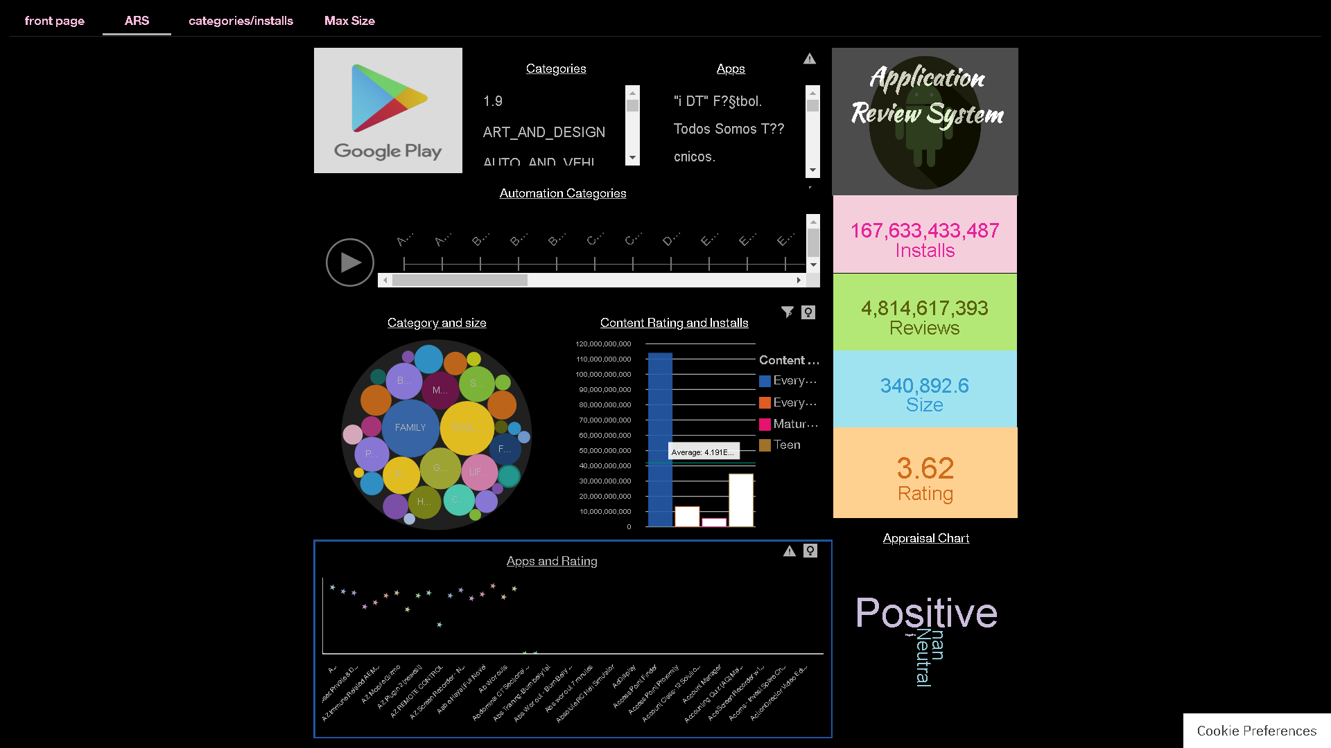

**Categories/ Installs dashboard**

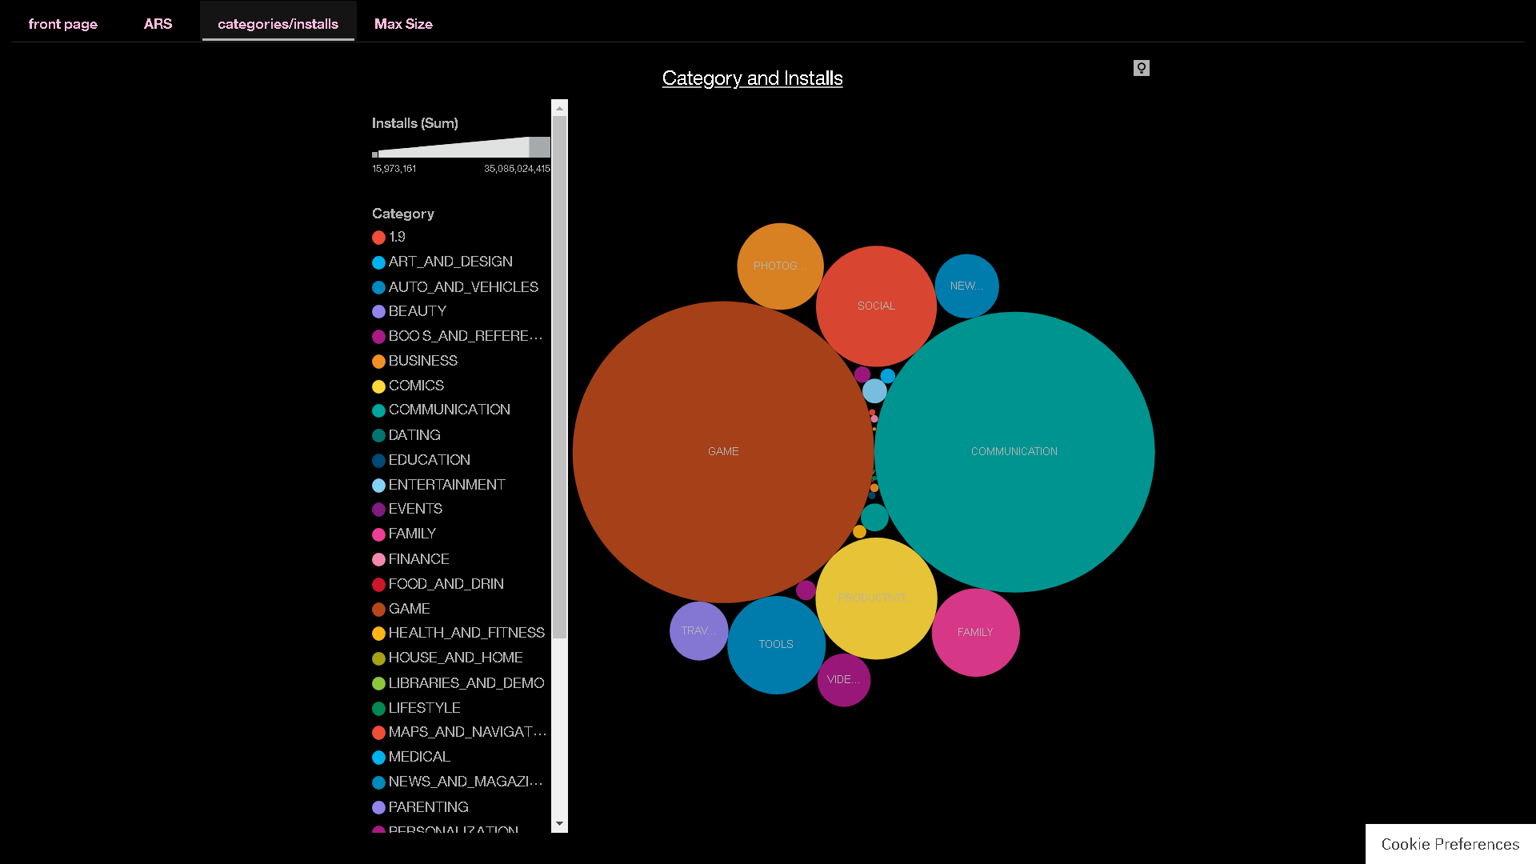

**Category/size dashboard**

